1. AZURE SUBCRIPTION –
   1. You can have more than one subscription
   2. It contains resources in multiple REGIONs
   3. And can contain TENANTS and multiple RESOURCE GROUPS and RESOURCES.
   4. You can relate this SUBSCRIPTION with your NEIGHBORHOOD

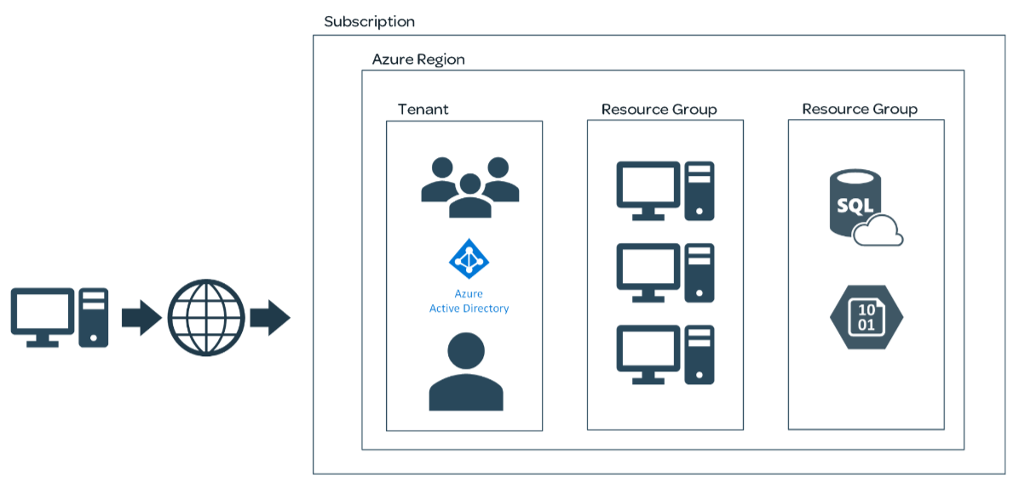

1. REGIONS
   1. Tied to a physical location
   2. Geographically separated locations that contains RESOURCES. Actually these are DATACENTERs present in different parts of the WORLD.
   3. We choose region either the RESOURCE we are looking for is available here (OR) it is closer to our CUSTOMERS base to whom we are serving.
   4. You as an ADMINSTRATOR responsible for the RESOURCES in this REGION.
2. TENANT
   1. We might have USERGROUP and USERS
   2. TENANT is also called as AZURE ACTIVE DIRECTORY. These are SYNONYMS
   3. TENANT = AZURE ACTIVE DIRECTORY
   4. We can have multiple REGIONS, RESOURCES within MULITPLE REGIONS WITHIN MULITPLE RESOURCE GROUPS housed within a SINGLE SUBSCRIPTION.
   5. We can have multiple TENANTs if it logically requires, like ONE TENANT for all corporate employee(INSIDE) and ANOTHER TENANT FOR USER CREDENTIALS FOR A WEBSITE THAT OUR COMPANY EXPOSES FOR OUR CUSTOMERS(OUTSIDE).
3. RESOURCE GROUPS
   1. There are multiple reasons on how RESOURCE GROUPS are logically created.
4. YOUR NEIGHBORHOOD analogy diagram

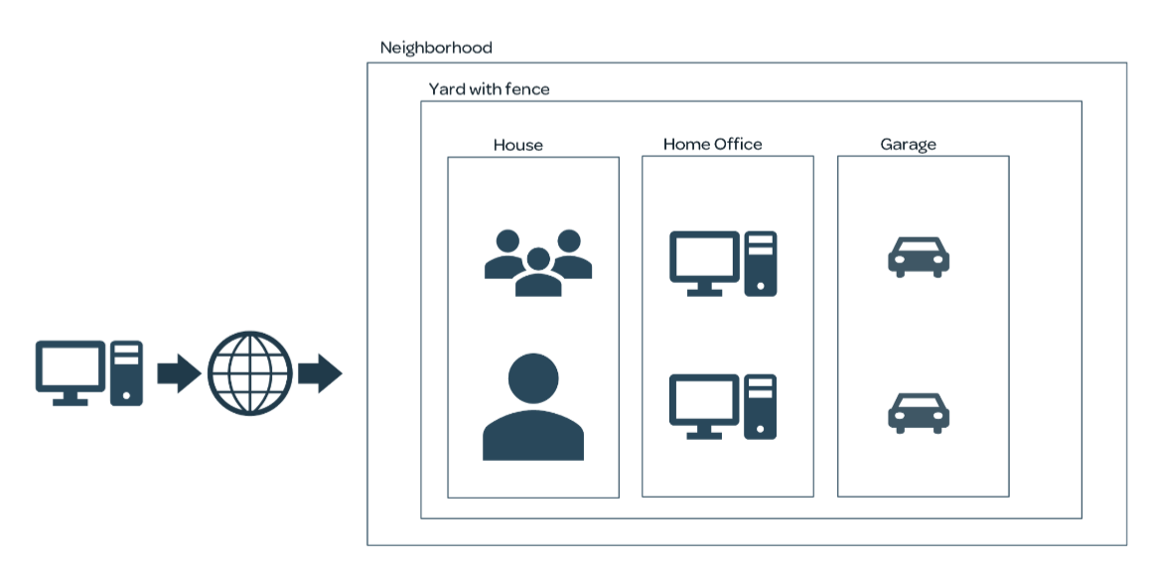

1. TAKE AWAY, THERE ARE MULTIPLE REASONS IN A WAY WE ORGANIZE AZURE SUBSCRIPTIONS, TENANTS, RESORUCE GROUPS.